**Access from Tokyo International Airport to Tsurumi University**

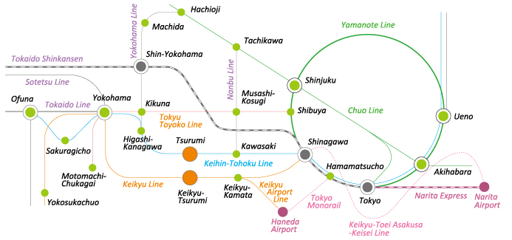

Tsurumi University is located in Tsurumi-ward of Yokohama City, 10 minutes walk from JR Tsurumi Station. It is relatively close from Tokyo Metropolitan.

You take flight from your country/region to Tokyo International Airports.

We have two Tokyo International Airports:

1. Tokyo **NARITA** International Airport

2. Tokyo **HANEDA** International Airport

**1. From Tokyo International NARITA Airport:**

The easiest way to come to Tsurumi is TRAIN (JR Line).

(There is no direct airport limousine bus from the airport to Tsurumi)

By train: JR Line

Convenient way (slightly more expensive: 3560 JPY, around 32 USD incl. reserved seat express fare: 1900 JPY=17 USD, you need to but the fare before riding)

・around 90 minutes in total from “Narita Airport Terminal St.” to “Tsurumi St.”

“Narita Airport Terminal St.” – “Shinagawa St.” (or “Tokyo St.”) with “Narita Express”, for 64(60) mins

“Shinagawa St.” (or “Tokyo St.”) – “Tsurumi St.” with “Keihin-Tohoku Line”, for 18 (27)

mins

Economic way: (1660 JPY, around 15 USD)

・around 120 minutes in total from “Narita Airport Terminal St.” to “Tsurumi St.”

“Narita Airport Terminal St.” – “Shinagawa St.” (or “Tokyo St.”) with “Sobu Kaisoku Line”, for 105 (95) mins

“Shinagawa St.” (or “Tokyo St.”) – “Tsurumi St.” with “Keihin-Tohoku Line”, for 18 (27)

mins

Rout from Narita Airport Terminal to Tsurumi St.

<http://www.haneda-tokyo-access.com/en/transport/trainlinemap.html>

searching train time

1.(JR Line) <http://www.jreast.co.jp/e/>

Time table for Narita Express from Narita Airport

<https://www.eki-net.com/pc/jreast-shinkansen-reservation/English/wb/common/timetable/e_nex_u/index.html>

2.

Narita Airport Terminal 1 St. to Tsurumi St.

<https://www.rome2rio.com/map/Narita-Airport-Terminal-1-Station/Tsurumi-Station>

Narita Airport Terminal 2-3 St. to Tsurumi St.

<https://www.rome2rio.com/map/Narita-Airport-Terminal-2-3-Station/Tsurumi-Station>

Convinient card for travel with JR, private train lines and underground:

SUICA / PASMO: e-money

<http://www.jreast.co.jp/e/pass/suica.html>

<https://www.jreast.co.jp/e/suicamoney/?src=gnavi>

* “SUICA” card is sold by JR lines and “PASMO” card is sold by private train lines and subways. You can use “SUICA” and “PASMO” for both JR and private lines and subways.

To get one, you would need at least 1000 JPY (500 JPY for deposit).



**2. From Tokyo International HANEDA Airport to Tsurumi**

The easiest way to come to Tsurumi is TRAIN (Keikyu Line).

(There is no direct airport limousine bus from the airport to Tsurumi)

By train: (Keihin Line)

・25 minutes from “HANEDA Airport International Terminal St.” to “Keikyu Tsurumi St.”

Rout from Haneda Airport to Keikyu Tsurumi St.

<http://www.haneda-tokyo-access.com/en/transport/trainlinemap.html>

**[ATTENTION]**

There are many 5 different train services and many destinations, therefore, it is VERY difficult to find right train to reach “Keikyu Tsurumi St”.

ONLY “LOCAL” and “Airport EXPRESS” stop at “Keikyu Tsurumi St” , BUT NOT ALL “LOCAL” and “Airport EXPRESS” go to direction to “Keikyu Tsurumi St” (the other direction to Shinagawa (Tokyo)).

So, please ask people at platform of Haneda St. whether it is going to “Keikyu Tsurumi St.” or use the following searching train time website.

searching train time

1.(Keikyu Line) <http://www.haneda-tokyo-access.com/en/>

2.<https://www.rome2rio.com/map/Haneda-Airport-International-Terminal-Station/Tsurumi-Station>

Convinient card for travel with JR, private train lines and underground:

SUICA / PASMO: e-money

<http://www.jreast.co.jp/e/pass/suica.html>

<https://www.jreast.co.jp/e/suicamoney/?src=gnavi>

* “SUICA” card is sold by JR lines and “PASMO” card is sold by private train lines and subways. You can use “SUICA” and “PASMO” for both JR and private lines and subways.

To get one, you would need at least 1000 JPY (500 JPY for deposit).

From Haneda Airport International Terminal St. to Keikyu Tsurumi St.

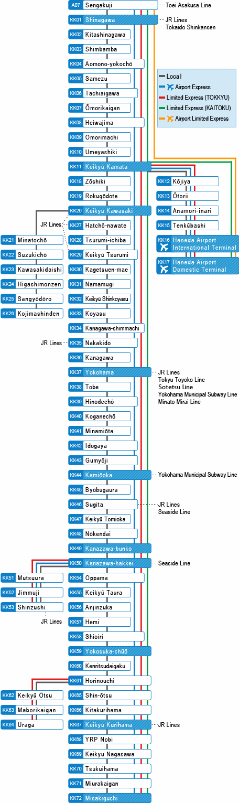

**Haneda Airport**

**International**

**Terminal**

Way to Yokohama St.

Way to Shinagawa St.

Haneda Airport

Domestic

Terminal

Keikyu Kamata St.

**Keikyu Tsurumi St.**